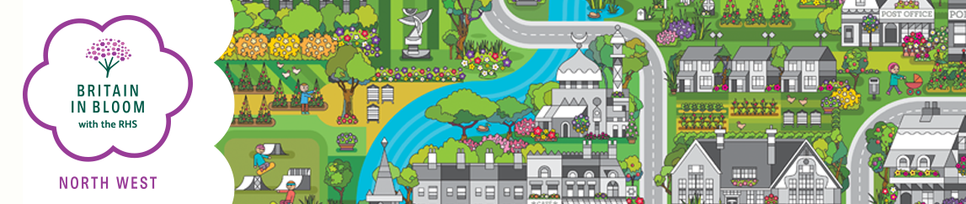

SCHOOLS JUDGING SHEET
Name of Entry: | Category:
Judge(s): | Judging Date:
SECTION 1- General | Possible  Marks |  | Marks  Awarded
Has a school action team been formed? | 10
SECTION 2 - Floral displays ( Design & Quality)
The appropriateness, impact and overall impression. | 15
Has there been pupil involvement in maintenance and design? | 30
SECTION 3 - Hard and soft landscaping projects
The appropriateness, impact and overall impression. | 15
Is there any pupil involvement? | 30
SECTION 4 - Environmental Quality
Was the school clean and tidy? | 20
Have there been any environmental initiatives undertaken/recycling? (paper /glass, etc) Nature projects (bird/bat boxes, wild flower meadows, vegetable growing, conservation areas (pond sites) | 40
SECTION 5 - Overall Impression
Has the school improved their environment and is it sustainable? | 10
Has the school received any other environmental awards? | 10
TOTAL POINTS AWARDED | 180
Areas of Achievement:

Areas for Development:

