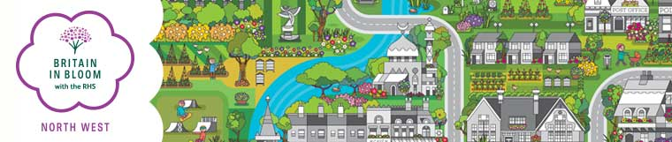
Schools and Britain in Bloom
North West in Bloom are part of two national programmes - Britain in Bloom and It’s Your Neighbourhood (IYN). These are both organised locally by North West Britain in Bloom.
In both of these programmes, involvement with young people and schools is encouraged. There is, however, often confusion as to how Schools fit into these programmes.
The IYN programme does not include a category for Schools unless they are part of a larger community initiative.
As part of a Britain in Bloom entry such as a City, Town or Village a single school can be included to demonstrate how Schools are involved in the campaign.
In the North West, this school will also receive a report from the judges and a Certificate of Achievement. The top performing schools (about 4) judged in this way will be invited to the Award ceremonies at the end of the year.
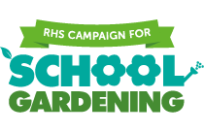
Unfortunately, North West In Bloom has not the capacity to judge any further schools and applications from schools in their own right cannot be accepted.
An alternative competition for schools is the RHS Campaign for School Gardening, https://schoolgardening.rhs.org.uk/home

