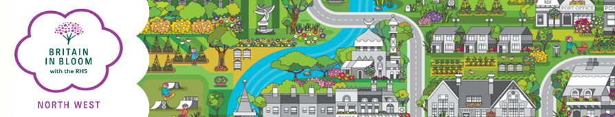
Britain in Bloom North West Entry Form 2024
For Admin Only
Group:
Entry:
Key Contact:
Area:
Co-ordinator:
Paid:
Status:

Please note:
A unique contact is required for each group that enters.

Name of Entry…….....................................................................................

This is the name that will appear on any award/certificate you may receive.

Contact Name…………………………....................Position……………………………………

Address……………………………….........................................................................

Post Code…………………….Tel No………………………….Mobile…………………………….…………

E-mail…………………………………………………………………….………….

BRITAIN IN BLOOM NORTH WEST CATEGORIES
CATEGORY | ELECTORAL ROLL NOs | CHARGE | TICK
Large City/MBC | over 200,001 | £250.00
City | 100,001 - 200,000 | £250.00
Small City | 35,001 - 100,000 | £235.00
Large Town | 12,001 - 35,000 | £175.00
Town | 6,001 - 12,000 | £140.00
Small Town | 2,501 - 6,000 | £120.00
Large Village | 1,001 - 2,500 | £85.00
Village | 301 - 1,000 | £80.00
Small Village | 300 and under | £65.00
Small Coastal Resort | 0 - 20,000 | £160.00
Large Coastal Resort | 20,001 and over | £220.00
Urban Community | 2,500 and over | £170.00
Town/City Centre | - | £120.00
Business Improvement District (BID) | - | £120.00
Local Authority Parks Large |  | £120.00
Local Authority Parks Small |  | £110.00
Pocket Park |  | £65.00
Payment (please tick):
Cheque/s payable to NORTHWEST IN BLOOM □
BACs payment: Account No. 10071623 Sort Code: 16-19-31 □
Please return (preferably by e-mail) by 31st March 2024 to:
Regional Organiser,
Rural Business Centre, Myerscough College, Bilsborrow, Preston, Lancashire, PR3 0RY.
Tel: 01995 642101
E-mail: info@northwestinbloom.com

