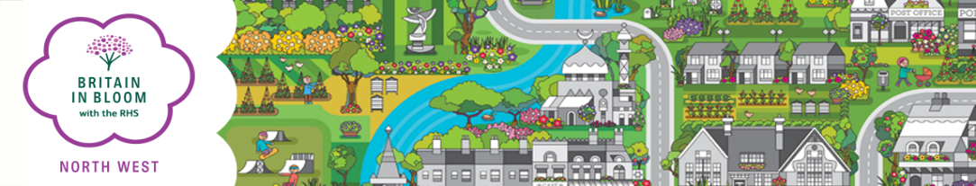
For Admin Only
Group:
Entry:
Key Contact:
Area:
Co-ordinator:
Paid:
Status:

Britain in Bloom North West Commercial Entry 2024

Please note:
A unique contact is required for each group that enters.

Name of Entry……....................................................................
This is the name that will appear on any award/certificate you may receive.

Post code of site (to help in locating the site for judging) …………………………….

Contact Name………………………………................. Position……………………………………………….........

Address………………………………...........................................................................................

Post Code……………………. Tel No………………………................Mobile:…………………………………………

E-mail…………………………………………………………………….…………..…..

BRITAIN IN BLOOM NORTH WEST COMMERCIAL CATEGORIES
CATEGORY | Size | CHARGE | TICK
Accommodation (Hotels & Public Houses)
Large | 20 rooms or above | £80.00
Small | Less than 20 rooms | £55.00
Tourist Attractions/Visitor Centres etc
Large | 25 Acres and above | £110.00
Small | Less than 25 Acres | £65.00
Retail/Commercial/Industrial Parks etc
Large | 25 Acres and above | £120.00
Small | Less than 25 Acres | £70.00
Caravan Park |  | £80.00
Hospital |  | £65.00

Payment (please tick):
Cheque/s payable to NORTHWEST IN BLOOM □
BACs payment : Account No. 10071623 Sort Code: 16-19-31 □

Please return (preferably by e-mail) by 31st March 2024 to:
Regional Organiser,
Rural Business Centre, Myerscough College, Bilsborrow, Preston, Lancashire
PR3 0RY
Tel: 01995 642101
E-mail: info@northwestinbloom.com

