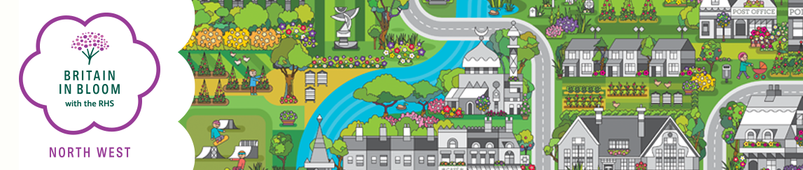

IT’S YOUR NEIGHBOURHOOD AWARDS - ASSESSORS REPORT
Name of Assessor(s): Award: Level
Name of Entry: Date:
SECTION A Community Participation | POSSIBLE  MARKS | Marks  Awarded
Has a neighbourhood action team been formed? | 15
Has there been an attempt to engage with the neighbourhood and other bodies? | 25
TOTAL SECTION A | 40
SECTION B Environmental Quality
Was the area clean and tidy? | 15
Has there been any environmental initiatives undertaken e.g. recycling composting undertaken by the neighbourhood? | 15
TOTAL SECTION B | 30
SECTION C Gardening Achievement
Design features plant choice and impact | 10
Standard of maintenance | 10
Enhancement through creativity and innovation | 5
Has gardening improved the area? | 5
TOTAL SECTION C | 30
TOTAL POINTS AWARDED | 100
Areas of Achievement: Positive responses to the pandemic

Areas for Development:

